**More About WV Birds** 

**DID YOU KNOW...** *West Virginia has over* [*170 breeding species of birds*](https://wvdnr.gov/birds-in-west-virginia/)*?*

[Common Birds of the West Virginia Botanic Garden](https://www.wvbg.org/education/species-lists/common-birds-of-the-wvbg/)

[Birds of WV Pocket Check List](https://wvstateparks.com/BirdsofWV_checklist.pdf) – from WV State Parks

Many of West Virginia’s birds are **migratory**, meaning they live in West Virginia during part of the year. The [Migratory Bird Treaty Act](https://fws.gov/birds/policies-and-regulations/laws-legislations/migratory-bird-treaty-act.php) prohibits the take (including killing, capturing, selling, trading, and transport) of protected migratory bird species without prior authorization by the U.S. Fish and Wildlife Service. We also aren’t allowed to collect evidence of these birds by law.

Some of our birds in WV like turkey and grouse are considered “game birds,” meaning they can be hunted at certain times of year. For more information, visit [WV DNR’s website](https://wvdnr.gov/hunting/hunting-regulations/) on hunting regulations.

**How Can I Watch Birds?**

Watching birds can be as simple as sitting by a window and keeping an eye on what comes and goes at the bird feeder. Or it can be much more of an adventure, like a planned trip to an exciting national wildlife reserve. Birdwatching is the *most revenue-producing hobby in the US*! Many avid birders will travel to distinct locations to see birds as they migrate, perform magical mating displays or rear young.

**Lucky for you, you can observe birds anywhere in West Virginia – for free!** If you want to watch birds in your backyard it’s important to follow good bird feeder hygiene and provide appropriate food types for our native birds.[Here is a good guide](https://extension.wvu.edu/natural-resources/wildlife/birds/backyard-feeding-basics) from the WVU Extension Service. There is a [Project Feeder Watch](https://feederwatch.org/) where you can participate in a bird count/survey! A fun national project and event is called the [Christmas Bird Count.](https://www.audubon.org/conservation/join-christmas-bird-count)

West Virginia has some amazing locations that are known for high populations of migrating birds. For example, you can visit [Hanging Raptor Observatory](https://visitwv.com/hanging-rock-raptor-observatory/) in Monroe County and see if you can volunteer in their annual migratory raptor counts!

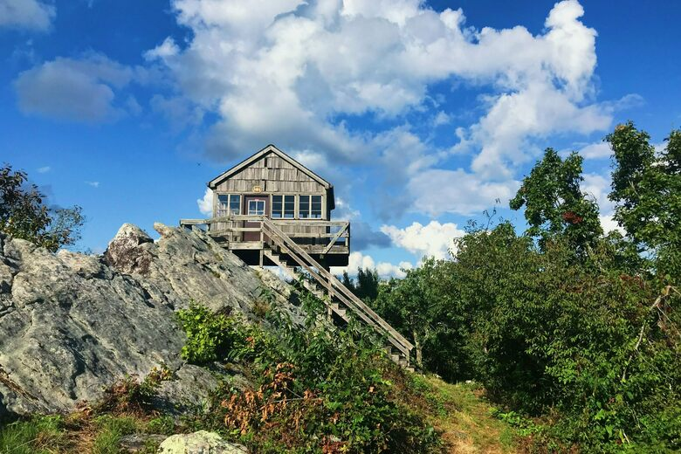 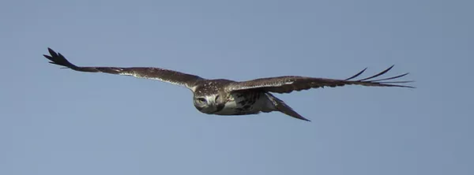

Photo of Hanging Rock courtesy of Atlas Obscura. Photo of hawk courtesy of Hanging Rock Observatory.

There are also *many* bird apps that can help you start identifying birds around you with the help of your smartphone.

**How Do Birds Get Injured?**

Most of the birds that are injured in West Virginia are hit by cars as they are migrating or are diving for prey that is close to roads. It’s important to think about how littering out of car windows can contribute to these birds being hurt.

If a person throws out an orange peel, it can attract mice or other small rodents to investigate the human food smell. While the mouse is feeding on the side of the road, a hawk can dive down to catch the mouse, putting it in danger of getting hit by a car. Even a mild collision can harm a bird to where it cannot fly effectively to survive.

Road salt in winter can also attract mammals looking for minerals, which can bring owls and other raptors to roadsides to hunt.

**What If I Find an Injured Bird?**

The first step is to call an avian rescue center to see if they can come and help capture the injured bird.

Avian Conservation Center of Appalachia: <https://www.accawv.org/>

Three Rivers Avian Center (TRAC): <http://www.tracwv.org/>

Here is a cool video of what it’s like to work in an Avian Rescue Center:

[TRAC Live Facility Tour](https://www.youtube.com/watch?v=YeAEe-A_8IA&list=PLZ2z1dGKYmg1t6gin3qUZPgN45tLAw21-)

*If you are not able to call a rescue center,* you can gently wrap the bird in a towel or a blanket to pick it up. If the bird is a raptor with large talons and a sharp beak; be careful to avoid contact with them as it might kick or bite you since it is scared. Then contain the bird in a sealable box that still has airflow, such as a cardboard box, and transport it to an animal hospital or the avian rescue center.

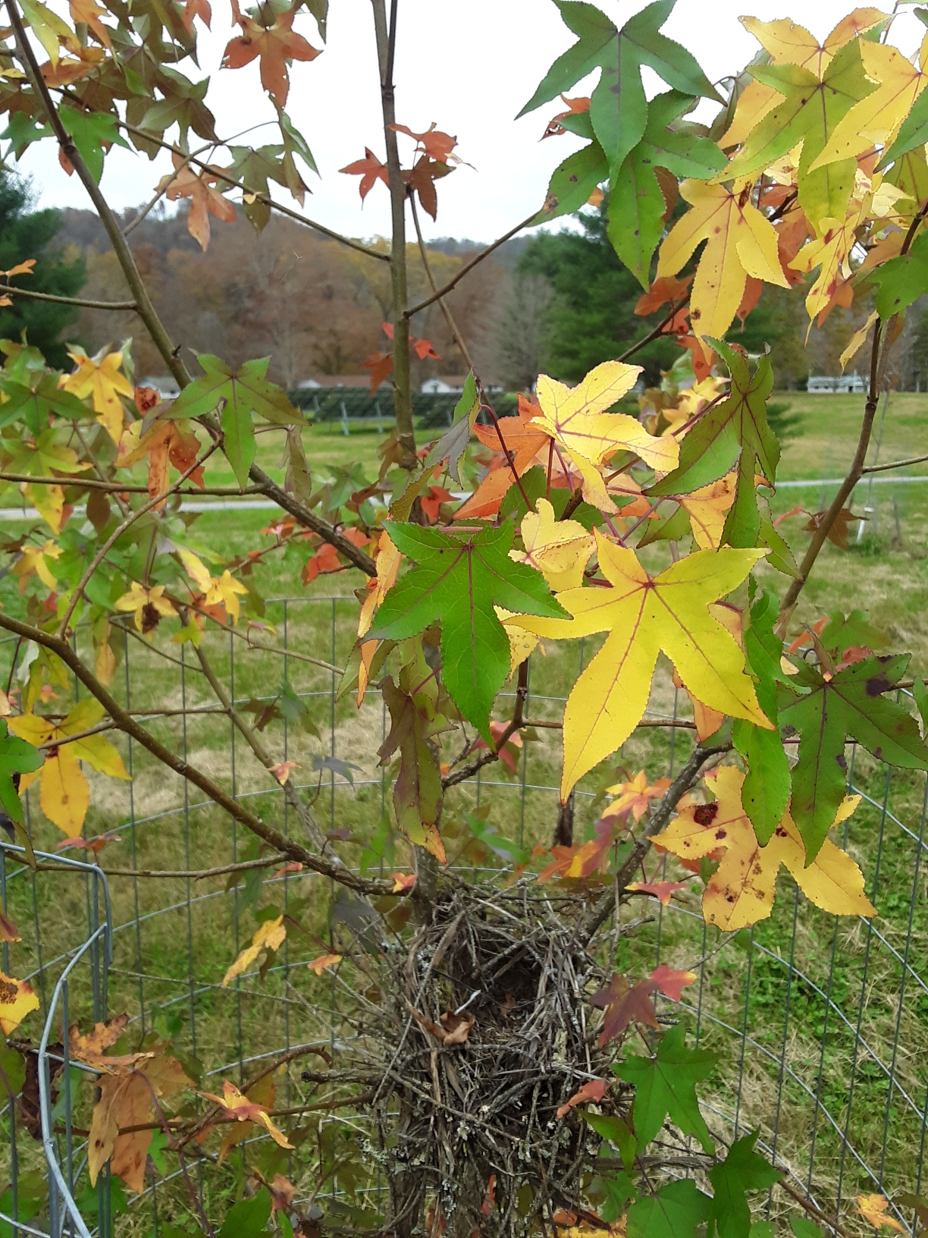

*Bird nest in a sweetgum tree at* [*Camp Waldo*](http://www.campwaldo.org)*.*

**How Can I Support Wild Birds?**

[**Wild bird populations across North America have been declining,**](https://www.birds.cornell.edu/home/bring-birds-back)even very common birds like blackbirds and sparrows. West Virginia is a refuge for many migratory birds that have lost habitat in surrounding states.

Here are some simple ways you can support our wild birds:

* **Plant a pollinator garden!** Did you know that about [96% of North America's birds](https://abcbirds.org/blog/insect-freefall/) feed insects to their young? Planting a native garden provides habitat for insects that eat plants and then bird can eat those insects and feed them to their babies
* **Don’t use pesticides in your yard.** Pesticides poison insects that will then be eaten by birds.
* **Encourage habitat.** Leave snags (fallen trees or limbs), and encourage multi-story habitat
* **Plant trees.**
* **Build nest boxes** (the right way!). Here are a few examples:

[How to Build an American Kestrel Box](https://www.wildlifecenter.org/sites/default/files/PDFs/Nestbox/American%20Kestrel%20Nest%20Box%20Plans.pdf)

[How to Build a Bluebird Box](https://www.audubon.org/news/diy-build-bluebird-box)

**Does Climate Change Affect Birds?**

***Yes!*** [Shifts in climate confuses them when migrating](https://www.nature.com/articles/s41598-021-01497-8.pdf), and they can fly off course, adding time and mileage to their trip.

The Audubon Society includes population projections for specific birds as they are affected by climate change. Try out their search tool here: <https://www.audubon.org/bird-guide>

[Profile on the Cerulean Warbler](https://www.audubon.org/field-guide/bird/cerulean-warbler), a threatened species in West Virginia

[Policy to Protect Birds](https://www.audubon.org/conservation/climate-states) - examples in different states

**More Fun with Birds**

**Wingspan:** A board game about birds’ roles in the ecosystem

Digital Copy Via Steam: <https://store.steampowered.com/app/1054490/Wingspan/>

Physical Copy: <https://boardgamegeekstore.com/products/wingspan>

**BIRD WORDS -** *Can you unscramble these bird-related words? Answers at bottom.*

1. STHREAFE – ________________________
2. KABE –_______________________
3. PANSGINW –_______________________
4. CARCASS –_______________________
5. RAPTOR –_______________________
6. PREDATOR –_______________________
7. GEG –_______________________
8. NETS –_______________________
9. BDHRIOSUE –_______________________
10. ANVIA –_______________________

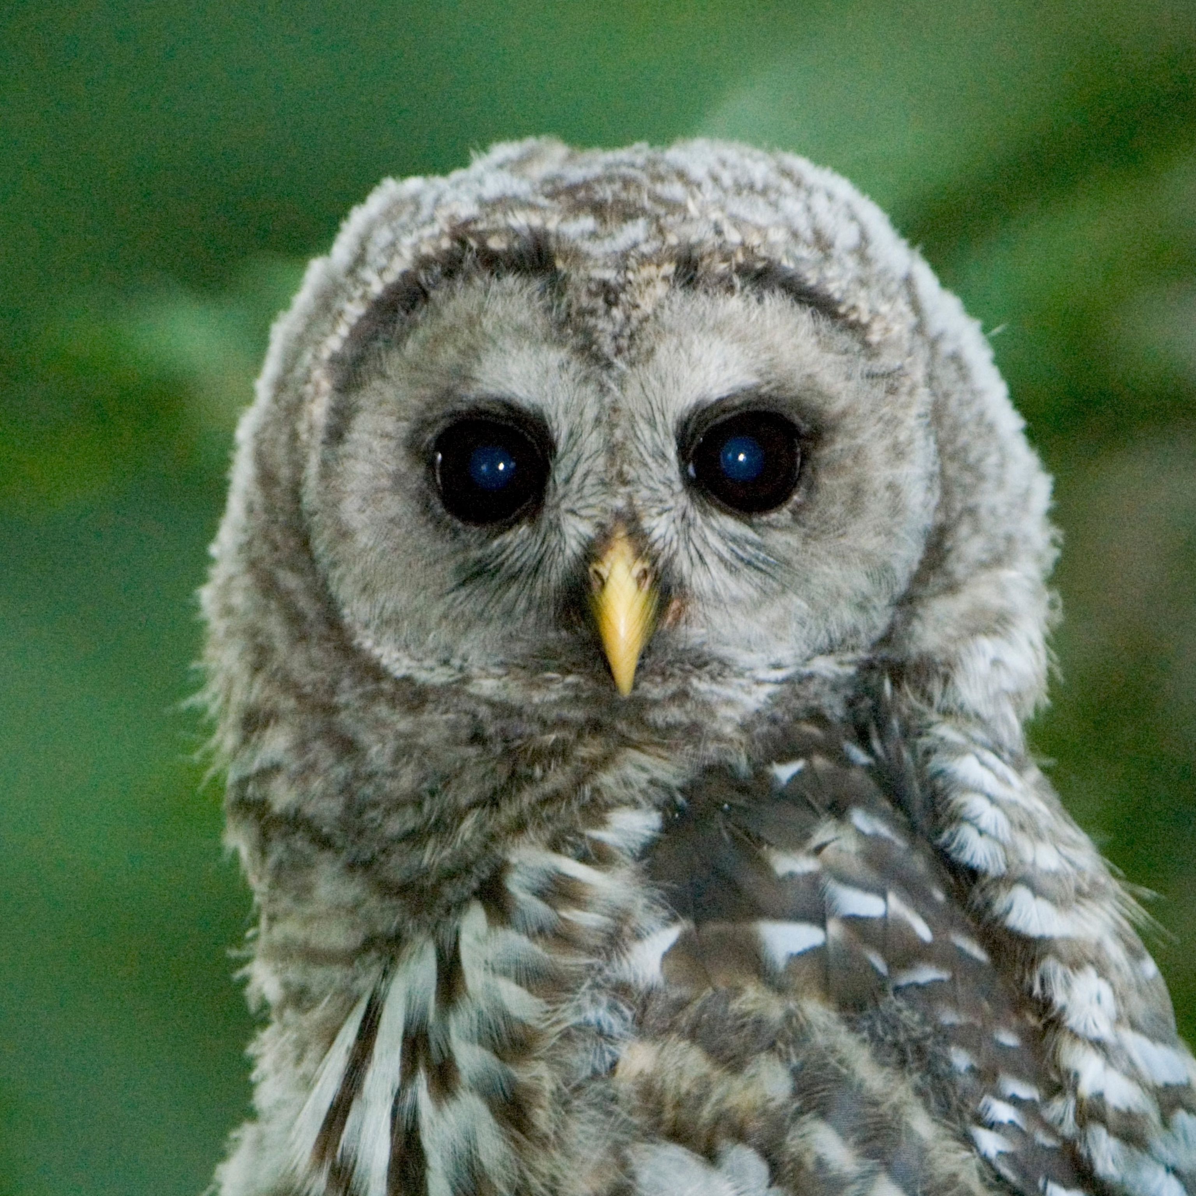

Photo credit: National Geographic

Answers: feathers, beak, wingspan, carcass, raptor, predator, egg, nest, birdhouse, avian