

**More Fun with Autumn Leaves**

**Predicting Fall Foliage**

West Virginia is one of the most beautiful places during fall foliage season! However, it can be hard to see the hues of red, orange and gold if you don’t know where or when to go to see them. A lot of factors can affect the timing of peak viewing season: tree species, drought and temperature. As an example, black gum (scientific name *Nyssa sylvatica*) is one of the first tree species in our area to change color and will often be bright red in a sea of green. Drought and temperature regulate how much moisture is in the cells of the leaf that can influence the time that a healthy full pigmented leaf stays on the tree. In order to plan your next family fall foliage “leaf peeping” trip, it can be helpful to learn about the basic fall color influencing factors. Smokeymountains.com offers a wonderful fall foliage prediction map for the entirety of the US. This offers a range of dates from August 30th to November 15th for you to see how foliage will be affected in the country. NOAA, the National Oceanic and Atmospheric Administration, also provides data and maps on the monthly temperature and precipitation of the US. This can help predict the changing of fall foliage for your leaf-peeping adventure.

So biologically, what makes leaves change color? Less rain and colder temperatures lead to death of the internal organelle responsible for green pigment, the chloroplast. This causes other pigments, called accessory pigments, to shine through. Anthocyanins, the pigments that cause red coloring, and carotenoids, the pigments that cause yellow and orange coloring, are the two main accessory pigments that are responsible for the colors in the fall foliage. These accessory pigments are constantly in the plant but are masked by the chlorophyll like a blanket during spring and summer.

Seeing the fall leaves is an amazing event that you can witness every year if you can plan accordingly!

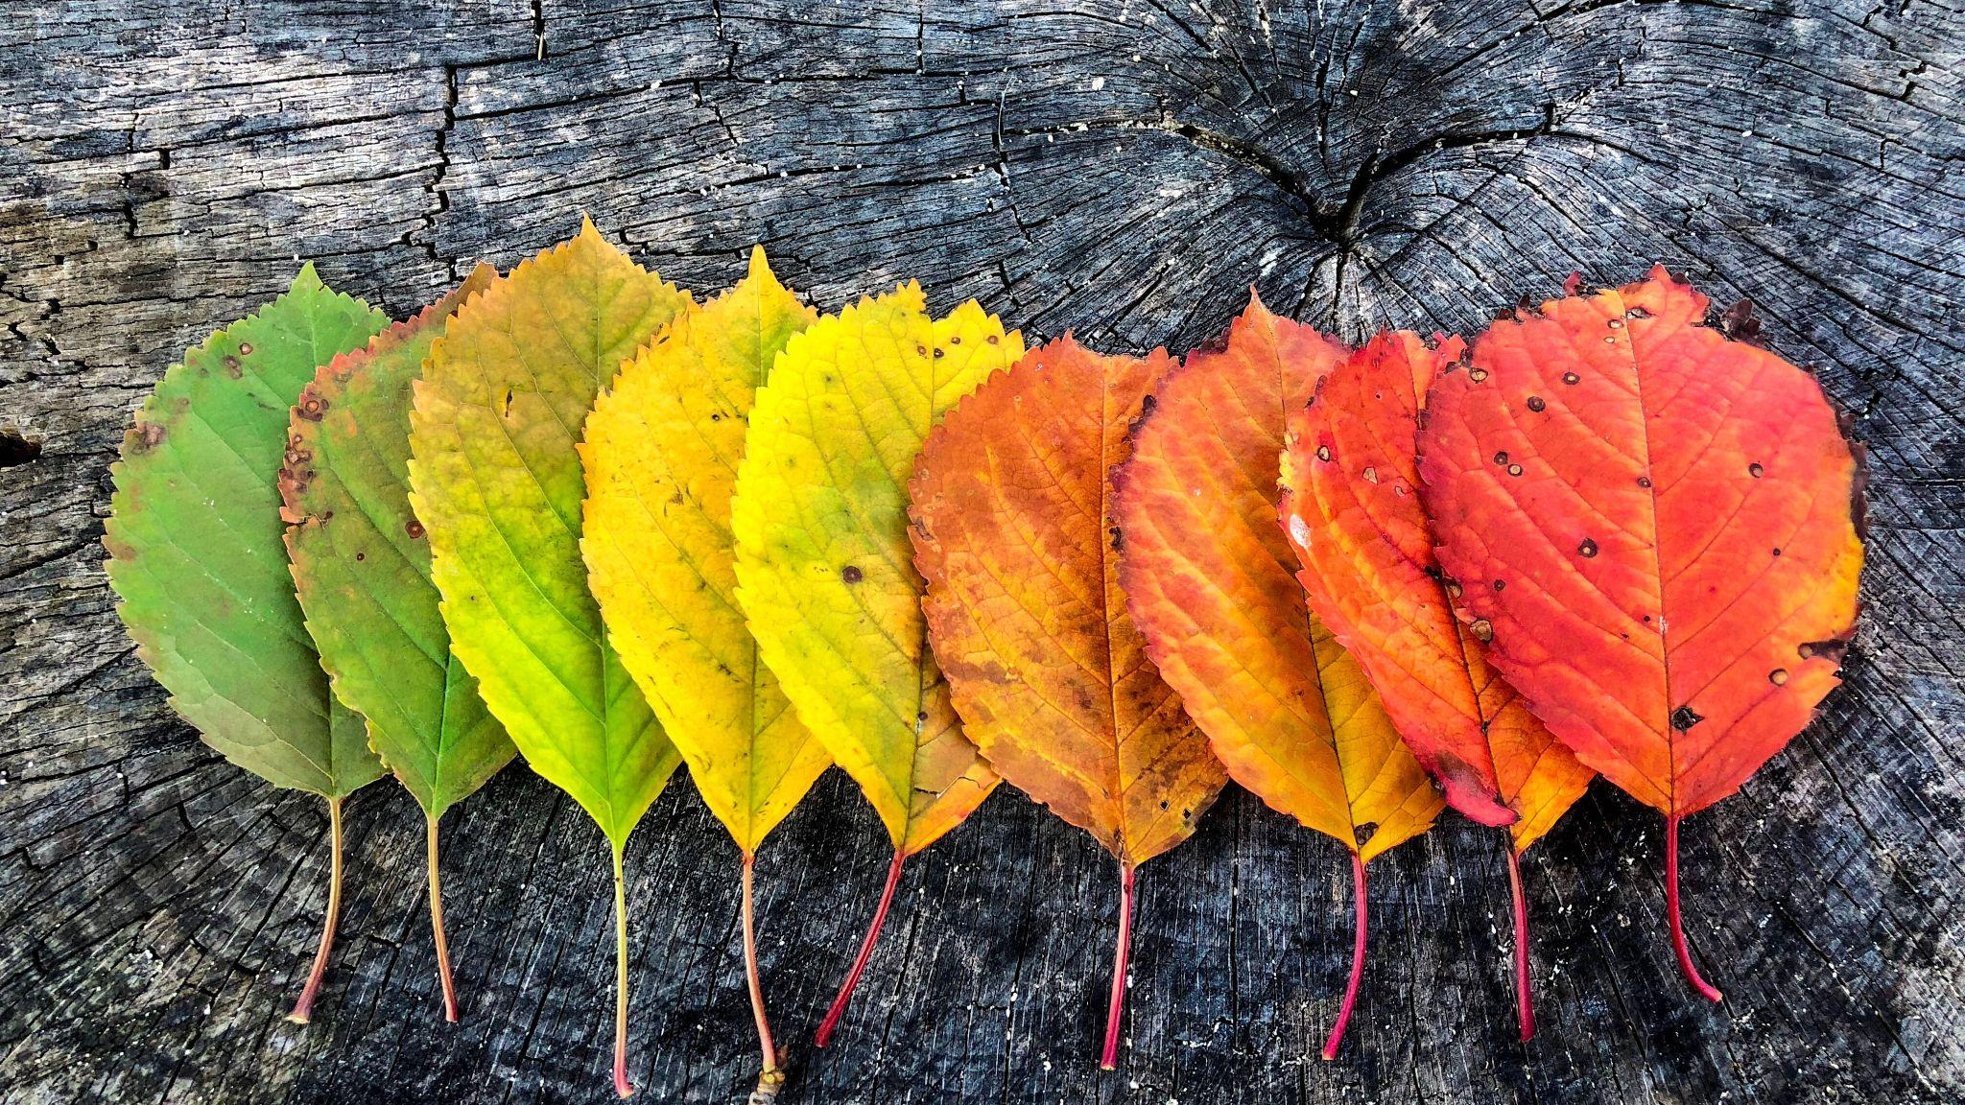

Photo by Savin Madeleine

[Smokey Mountains 2021 Fall Foliage Map](https://smokymountains.com/fall-foliage-map/)

[How to Predict the Peak Time for Fall Leaf Foliage](https://todayshomeowner.com/predicting-the-peak-of-fall-foliage/)

[How to predict fall color | A Fruitful Discussion](https://site.extension.uga.edu/fannin-gilmer/2020/10/how-to-predict-fall-color/)

[United States Yearly and Monthly Mean Total Precipitation](https://www.eldoradoweather.com/climate/US%20Climate%20Maps/Lower%2048%20States/Precipitation/Mean%20Total%20Precipitation/Gallery/mean-total-precipitation.html#location1)

[National Temperature Maps](https://www.ncdc.noaa.gov/temp-and-precip/us-maps/1/202108?products%5B%5D=prcp-total)

[Why Do Leaves Change Color in Autumn?](https://www.treehugger.com/why-do-leaves-change-color-autumn-4869632)

**Do all Trees Change to the Same Color?**

No, depending on the tree species, trees can be an array of colors! With the large amount of diversity in West Virginia you are able to see all of the colors that the trees offer in the fall ranging from yellow to purple. This makes our state one of the most beautiful during the fall season. Our state tree, the sugar maple (scientific name *Acer saccharum*), can create a mixture of a beautiful pink, yellow and orange display. Learning individual tree species can help you predict locations for your leaf peeping road trip throughout the mountain state.

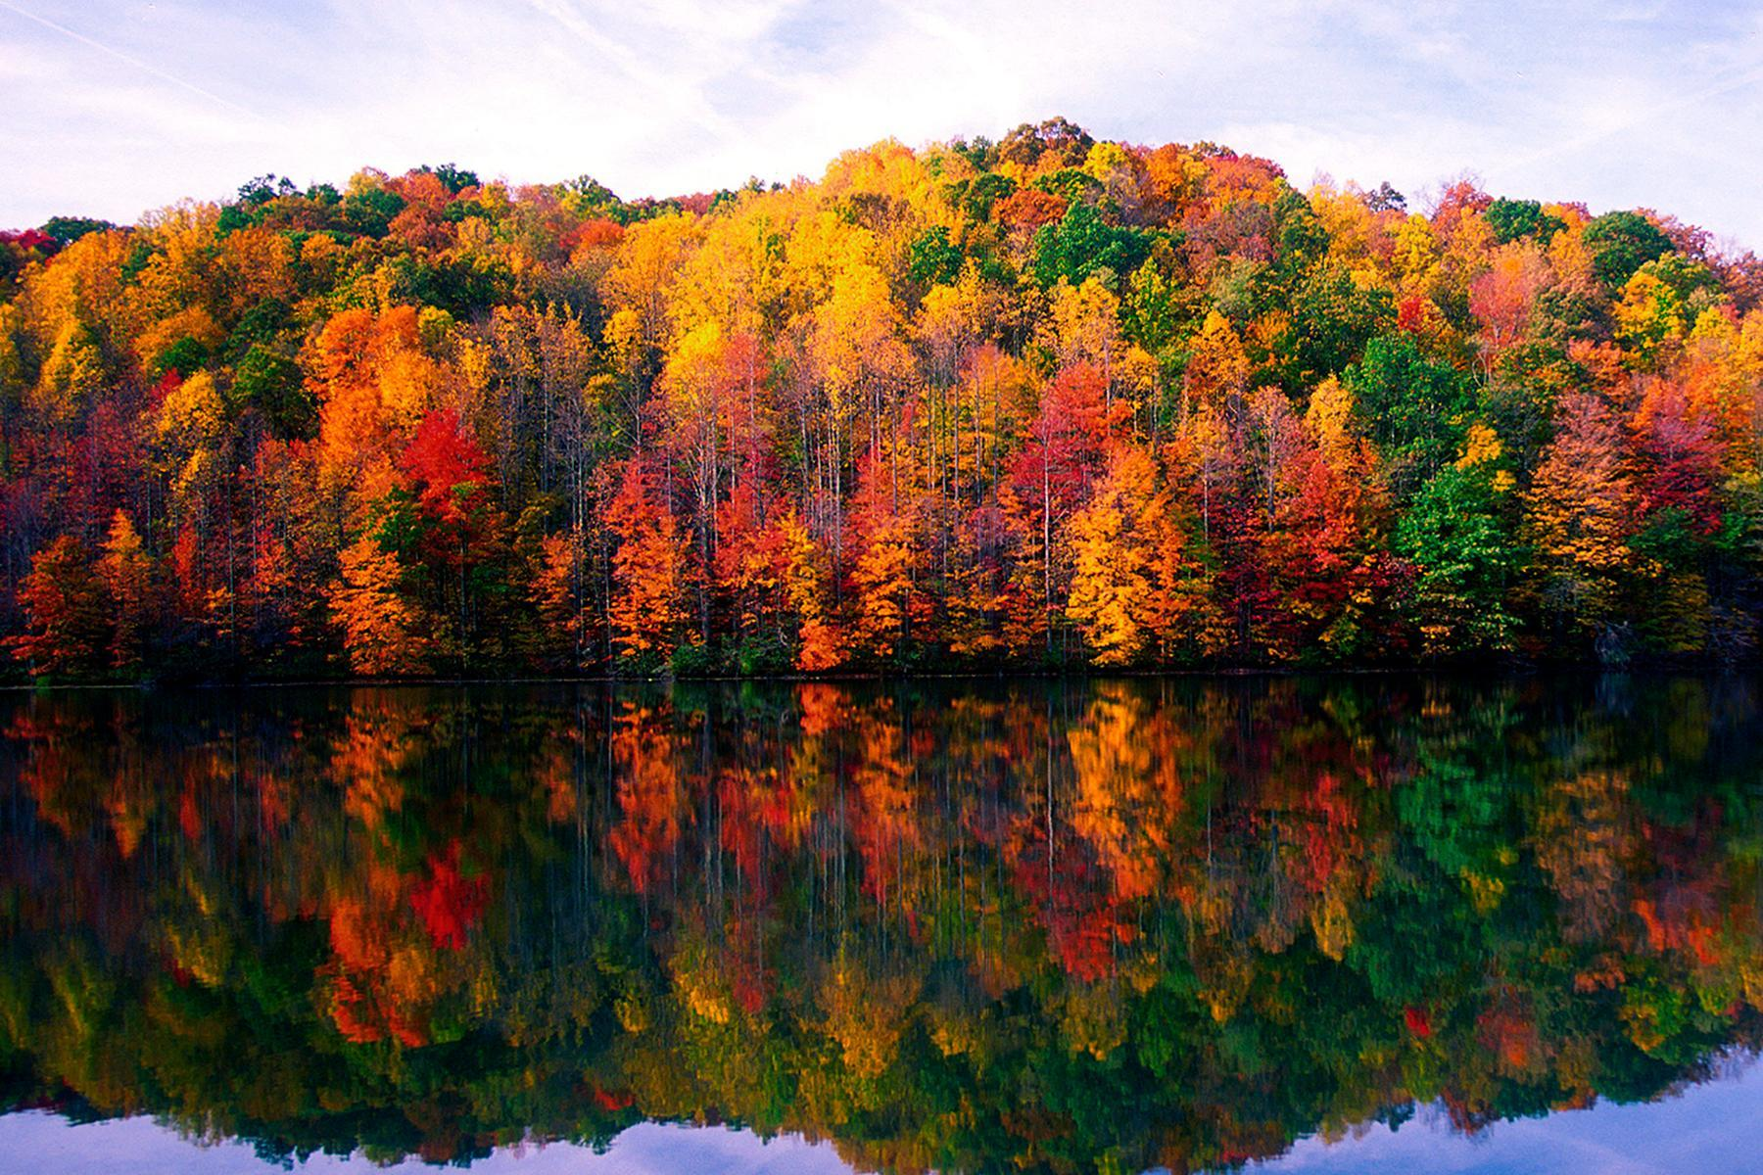

Photo courtesy of West Virginia Tourism

[WV Fall Foliage](https://wvforestry.com/wv-fall-foliage/)

[West Virginia Trees](https://wvforestry.com/pdf/Tree%20ID.pdf)

[West Virginia Has Amazing Fall Foliage — Here Are the Best Places to See It](https://www.travelandleisure.com/trip-ideas/fall-vacations/west-virginia-fall-foliage-destinations)

**Leaves are a Part of the Ecosystem!**

Fallen tree leaves are a vital part of every ecosystem. They provide food and shelter to many species of plants and animals. Without these habitat features ecosystems struggle. Small animals and arthropods, such as pill bugs and millipedes, feed on the rotting layer of leaves. Beetles, mollusks, and wolf spiders use leaf piles as a way to hunt by trapping prey in the maze of lead layers. Many birds such as wild turkeys, blue jays, and thrushes also use the leaves to feed on during the winter months. Some other bird species use the leaves as nesting material or even a place to hide nuts for winter. Caterpillars, like the beautiful luna moth, pupate in leaves in our yards to emerge next year as a beautiful green moth. As you can see, leaving leaf piles is beneficial for many species of plants and animals. Spending your time to clear all of the leaves in your yard can be wasteful and harmful to the environment. Instead, if you could leave it for the animals to use and promote a healthy ecosystem. As an added bonus, doing so can be helpful in lowering your carbon footprint by not using leaf blowers or other devices that use electricity or by throwing out leaves in plastic trash bags.

Additionally, this is an excellent opportunity to study your ecosystem! Leave big piles of leaves until part of them are starting to decompose. Take this time to observe all of the organisms in your leaf pile. What are they doing? Why do you think they’re there? This shows how important the leaves are for the ecosystem. Think about the ecosystem before you start raking up leaves this year!

See last page for activity with fallen leaves!

[Life in the Fallen Leaves – Loudoun Wildlife Conservancy](https://loudounwildlife.org/2012/10/life-in-the-fallen-leaves/)

[6 Excuses to Avoid Yard Work This Fall](https://blog.nwf.org/2013/11/6-excuses-to-avoid-yard-work-this-fall/)

**Nature’s Notebook**

Nature’s notebook is a website that allows you to record observations about the plants and animals around you. It uses phenology, the study of biological changes that are caused by seasonal and environmental factors, to better track data for plants and

animals. Nature’s notebook has been adapted for many different regions and species and can help us better understand how phenology affects nature. All you need to do is sign up for a Nature’s Notebook account, select the species you’re studying and start observing! This can provide information to scientists that can help understand and protect your local ecosystem.

**How to sign up for Nature’s Notebook:**

[Green wave | USA National Phenology Network](https://www.usanpn.org/nn/Greenwave)

[Nature's Notebook Activities | USA National Phenology Network](https://www.usanpn.org/nn/educate/activites)

**Fun Art Projects with Fall Foliage!**

Art is one of the best ways to express yourself. It can also help teach others about the things around you. Autumn leaves can be used as creative and fun decorations for home and the classroom. Just gather leaves from your backyard and get to crafting! You can make leaf crowns, wreaths, and almost anything you can think of. You can also use Autumn leaves to learn about nature’s symmetry.

Tree leaves have bilateral symmetry, meaning that if they were split in half or folded in the correct orientation the two sides would be identical to each other. A lot of things in nature have this symmetry such as dogs, sharks, and even humans! Placing a half-cut leaf down on a sheet of paper and recreating it for your own can help you learn more about symmetry.

How are these West Virginia native tree species’ leaves bi-laterally symmetrical? Draw a line to best show where the leaves are symetrical.

tulip poplar red maple black walnut

(*Liriodendron tulipifera*) (*Acer rubrum*) (Juglans nigra)

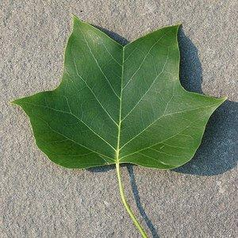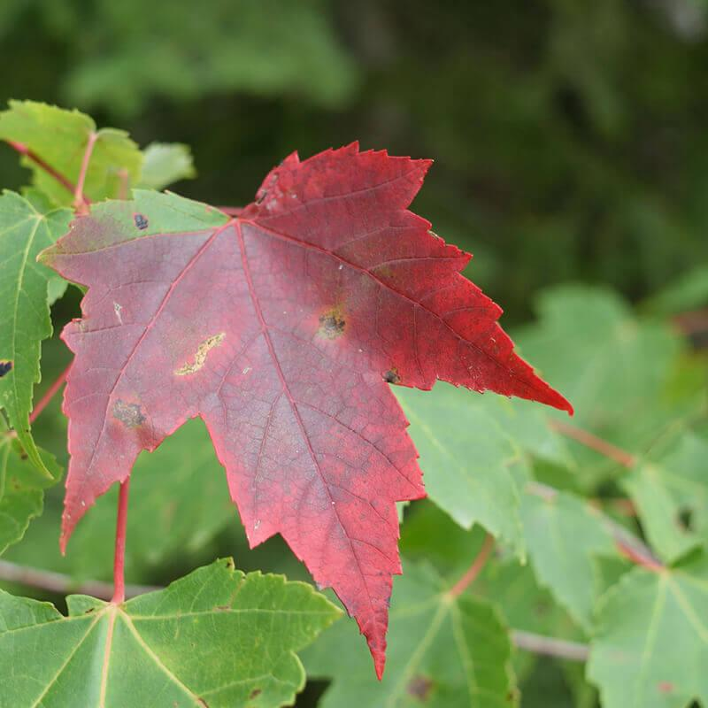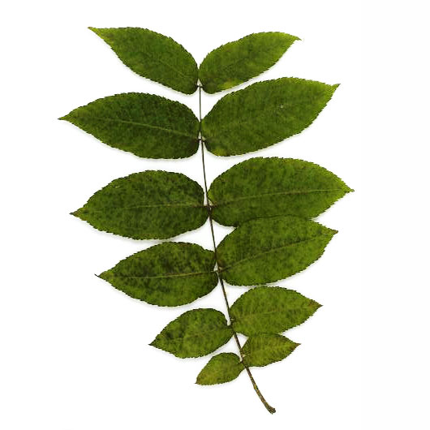

Photo by Derek Ramsay Photo from [The Original Garden](https://theoriginalgarden.com/p/seeds/seeds-trees-shrubs/trees/acer-rubrum-red-maple) Photo by [NYC Street Tree Map](https://tree-map.nycgovparks.org/tree-map/species/45200)

[Autumn Leaf Crown](https://theimaginationtree.com/autumn-leaf-crown/)

[How to Make an Easy Autumn Leaf Wreath for Kids](https://artfulparent.com/a-beautiful-diy-autumn-leaf-wreath/)

[Mirror Leaf Drawings: Nature Art](https://theimaginationtree.com/mirror-leaf-drawings-nature-art/)

Leaf Pile Observation Log

What do you think you will see? (Insects? Amphibians? Eggs? What else?) ________________________________________________________________________________________________________________________________________________________________________________________________________________________________

Where are you observing? ________________

What date & time did you start and end your observation?

Date: _________Start time: _______ End time: ________

What did you see in your observation? Why do you think it’s there? Describe this in as much detail as you can.

________________________________________________________________________________________________________________________________________________________________________________________________________________________________________________________________________________________

Draw anything you’re not sure how to describe

|  |
| --- |
|  |

How is this different from what you thought you would see? Were you right or wrong, how so?

________________________________________________________________________________________________________________________________________________________________________________________________________________________________________________________________________________________