**More on Exploring the Outdoors in WV**

***How is a Wilderness Area different from a National Park or National Forest?***

**National Park**

The National Park Service was created in 1872. The first areas to de designated as parks were preserved to be “a public park or pleasuring-ground for the benefit and enjoyment of the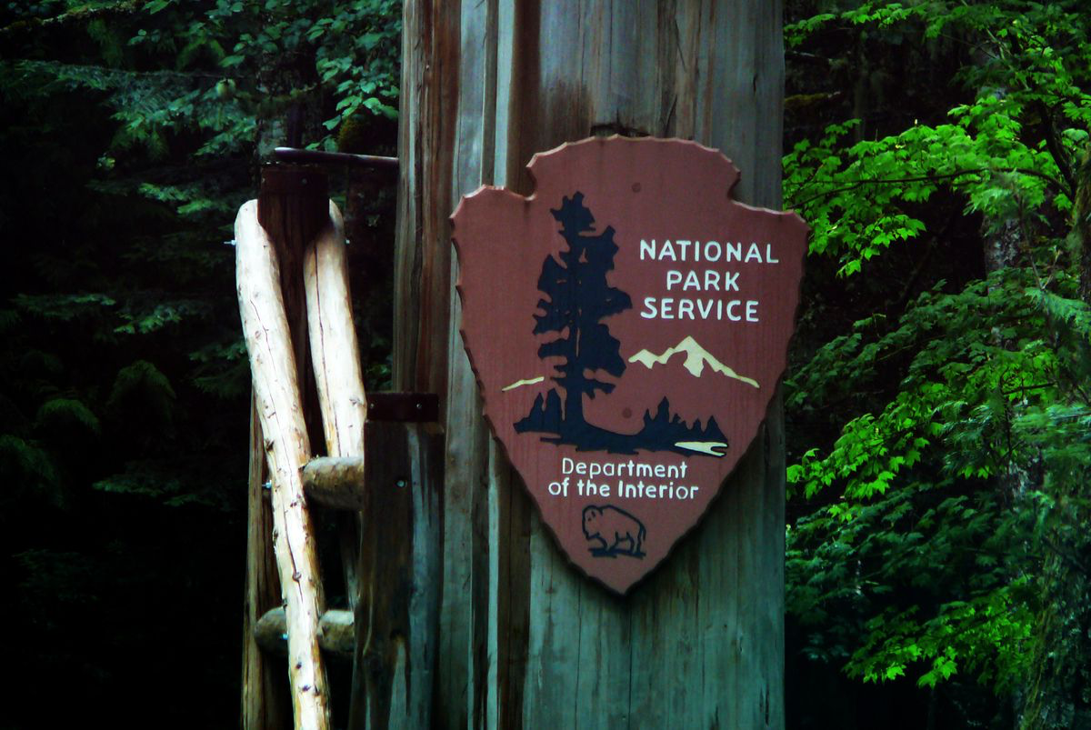 people”. National Parks today mostly still focus on the experience of the visitor. However, they are also leaders in conservation and outdoor education. Trails are maintained by crews and Park Rangers play the role of outdoor teachers - leading nature hikes, giving talks, and guiding visitors to distinct ecological / geological features in each park.

[**Learn More about the National Park System**](https://www.nps.gov/aboutus/national-park-system.htm)

West Virginia recently inaugurated a National Park: **The New River Gorge!** Click the link below to learn about a beautiful National Park in your backyard.

[**New River Gorge National Park and Preserve**](https://www.nps.gov/neri/index.htm)

**National Forest**

National Forests also provide exciting opportunities for outdoor activities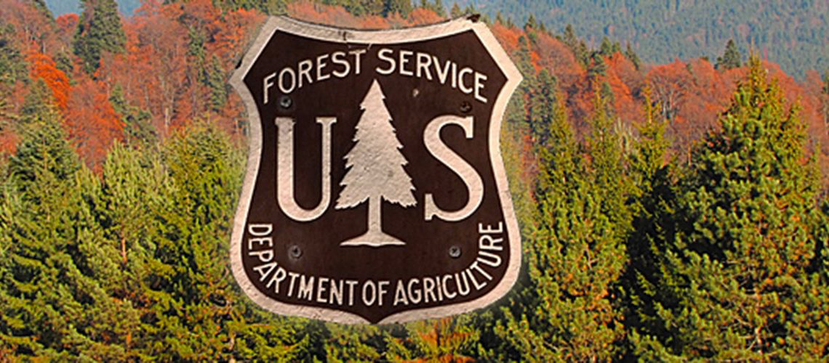 like hiking, mountain biking and wildlife viewing. National Forests are different that National Parks in that they are mostly set aside as forest timber reserves or wildlife habitat resources. Hunting and foraging is allowed in National Forests with proper permits. These lands are taken care of by the United States Forest Service, made up of natural resource professionals with a multitude of scientific skills. The US Forest Service acts as a scientific liaison to universities and research groups that help us understand conservation issues such a prescribed fire rotations, wildlife habitat and endangered species habitat requirements.

[**Learn More about the United States Forest Service**](https://www.fs.usda.gov)

**Wilderness Area**

Wilderness areas are places that are left in a natural state, where impacts from human activities are minimal—that is, as a wilderness would be without human influence. Think of a wilderness area like an animal’s home that you are visiting and respecting. It might also be called a *wild* or *natural* area.

Wilderness areas are designated within existing public land, like a National Forest or Park. Low-impact recreational activities are sometimes allowed in these areas - like hiking, fishing and cross-country skiing - but development is prohibited by law. Chainsaws and bikes are prohibited in wilderness areas because of their impact on wildlife, like frightening sounds and quick movement.

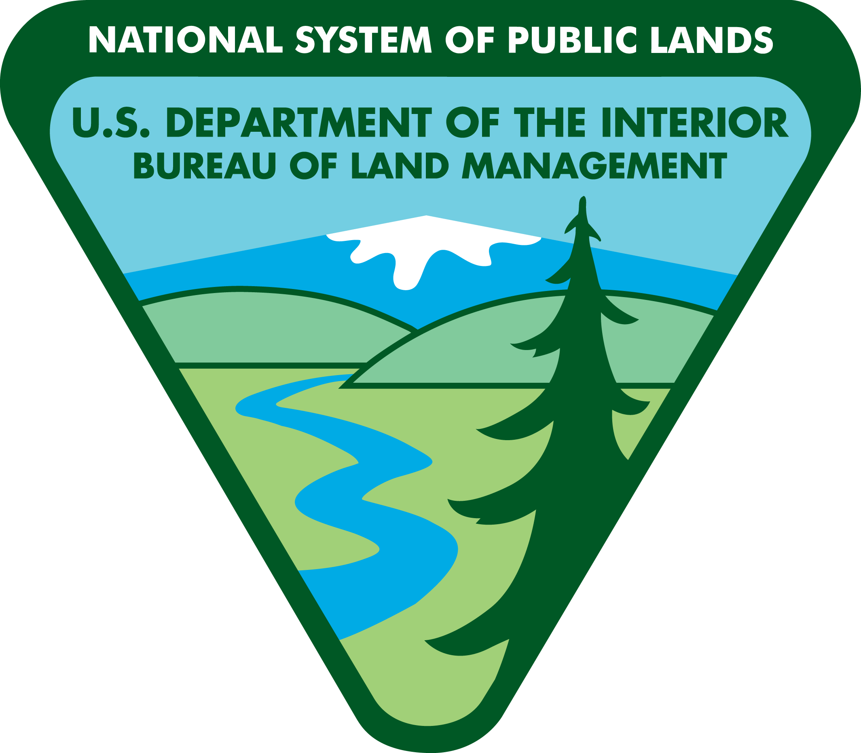Wilderness areas in the United States are managed by four main government agencies: The Bureau of Land Management, the United States Fish and Wildlife Service, the United States National Park Service and the United States Forest Service. Some wilderness areas are specifically set aside as habitat for rare and endangered species, or for unique geological features. To learn more about wilderness areas, visit the links below.

[**Video about Wilderness**](https://vimeo.com/139304553)

[**Discover Wilderness Areas**](https://www.publiclands.com/blog/a/discover-wilderness-areas)

[**Nicodemus Wilderness Project**](https://wildernessproject.org/environmentalinks.php)

[**Interactive Map of Wilderness Areas in the US**](https://umontana.maps.arcgis.com/apps/webappviewer/index.html?id=a415bca07f0a4bee9f0e894b0db5c3b6)

[**Quick Facts about our Wilderness Areas**](https://wilderness.net/learn-about-wilderness/fast-facts/default.php)

[**About Wilderness Stewards**](https://www.wildernessstewards.org)

All the Wilderness Areas in West Virginia are in the **Monongahela National Forest**, except for Mountain Lake Wilderness which straddles the Virginia-West Virginia state line in the George Washington and Jefferson National Forests.

[**West Virginia Wilderness Areas**](https://www.fs.usda.gov/detail/mnf/specialplaces/?cid=stelprdb5084288)

One of the most popular wilderness areas in the Mountain State is the beautiful Cranberry Wilderness. It has miles of rugged hiking trails perfect for a backpacking trip and wildlife viewing. The Cranberry Wilderness also has a boardwalk that gives visitors a closeup view of the unique bog ecosystem.

[**Trail Map of Cranberry Wilderness**](https://www.fs.usda.gov/Internet/FSE_DOCUMENTS/stelprdb5195772.pdf)

[**Cranberry Wilderness Information**](https://www.fs.usda.gov/Internet/FSE_DOCUMENTS/stelprdb5090665.pdf)

**Leave No Trace**

One of the most important things to take with you when you visit a wilderness area isn’t a backpack or a map - it’s the mindset to **Leave No Trace**. Leave No Trace is an approach to being in nature that respects wildlife and ensures that it will be as pristine for future generations to enjoy. Some of the Leave No Trace principles may seem obvious – like respecting wildlife and not littering. Leave No Trace also includes not moving firewood from place to place because it can move insect pests and pathogens, not digging up plants, and staying on trails. Stepping off the trail can potentially kill a sensitive plant species!

Visit the official Leave No Trace Organization’s website to learn more about how you can contribute to preserving wild spaces. Leave No Trace also has guidelines about how you share about your wilderness experience – such as on social media – so that you encourage respectful practices and don’t promote others.

[**Leave No Trace Website**](https://lnt.org/)

[**Seven Principles of Leave No Trace**](https://www.nps.gov/articles/leave-no-trace-seven-principles.htm)

Below is a list of questions that can act as a fun group activity.

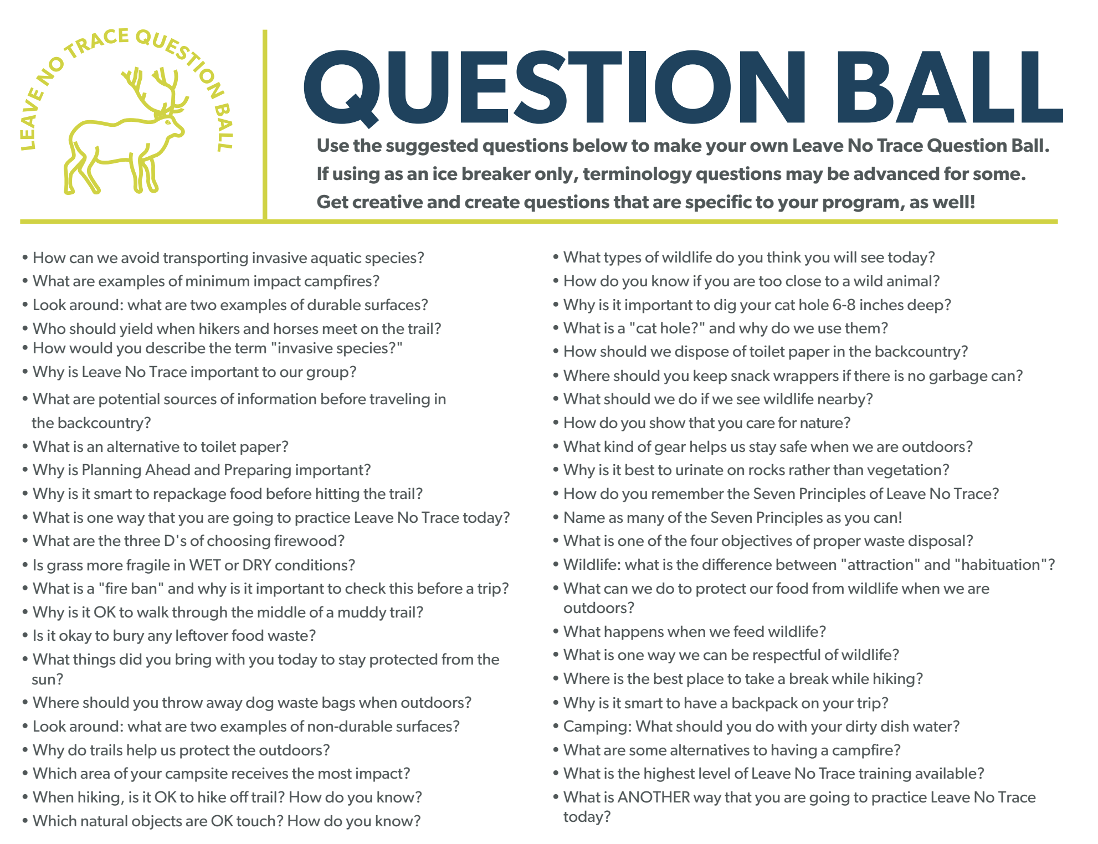

**Geocaching**

Geocaching is an outdoor activity that is just like treasure hunting! It might not be for gold coins, but you truly never know what you will find in a geocache. To find a geocache you visit the below website and follow the clues in real life forests and wild areas to find a sealed capsule that others have hidden.

[**Find a Geocache Near You**](http://www.geocaching.com)

**Identification Apps**

To learn more about what is in the woods around you there are several apps that can help identify plants, animals and more. Some popular ID apps are: iNaturalist, Seek, eBird, Flora of Virginia, and Merlin (for birds).

**Every Kid Outdoors Program**

[This a national program](https://everykidoutdoors.gov/index.htm) where all 4th graders can explore America’s natural wonders and historic sites FOR FREE.

**Wilderness Area Word Search**

Find activities that you can do in wilderness areas! Remember that these are activities that don’t involve motorized or mechanical tools to respect animals’ habitat and other visitors’ solitude. Some activities might require a permit (like foraging and hunting). Be sure to check beforehand.



