**More Fun with Freshwater Mussels**

**What is a filter feeder?**

The animal kingdom is filled with many different types of animals with unique ways of living and behaving. This includes **a lot** of different eating habits. Freshwater mussels are animals that primarily eat using a process called ***filter feeding****.*

In filter feeding, mussels bring in large amounts of water from the surrounding area and filter out the small algae, bacteria and ***phytoplankton*** – tiny photosynthetic organisms in fresh and saltwater - to eat. They also use this method to extract oxygen from the water that they send to their gills to breathe.

Filter feeding not only supplies mussels with the food and oxygen they need, but also filters small particles and toxic substances out of the water of the river or creek that the muscles live in. **A single mussel can filter up to 15 gallons of water a day!**

The presence of healthy mussel populations can be extremely important in maintaining the health of the entire ecosystem. Mussels lower the chances of ***eutrophication*** by filter feeding. Eutrophication is the response to excessive nutrients in water by phytoplankton and algae. These microorganisms can reproduce heavily and utilize all the oxygen out of the water. This causes other animals that need oxygen in the environment to move to a new location, or n some cases, to die.

[Filter Feeders](https://newportbay.org/wildlife/marine-life/filter-feeders/)

[What Is a Filter Feeder?](https://www.thoughtco.com/what-is-a-filter-feeder-2291891)

[Mussels are filter feeders](https://www.sciencelearn.org.nz/videos/366-mussels-are-filter-feeders)

[Eutrophication](https://oceanservice.noaa.gov/facts/eutrophication.html)

**What is a parasite?**

A ***parasite*** is an organism that lives off of another organism in a way that is damaging to its host and does not give any benefit. A common example of a parasite is a tapeworm. These are commonly found in household pets like dogs and cats. Tapeworms get into an animal's digestive system and settle in the small intestines and feed off food that the cat or dog should be digesting for their own health and energy.

Some freshwater mussels are also parasites during one of their young life stages, called a larvae. The mussel larvae attach on the gills of fish and turn into a capsule inside the fish they are feeding on. They go through a stage of ***metamorphosis*** after weeks of feeding of the fish in which they fall out of the host fish after they have stolen enough energy by being a parasite of the fish.

Some species of mussels have only one species of host fish that they can be a parasite of. These relationships can be so specific and mysterious that many have not yet been discovered or fully described to science.

[Parasitic Relationships](https://necsi.edu/parasitic-relationships)

[Parasitic Mussels](https://www.nationalgeographic.com/animals/article/animals-parasites-mussels-fish-freshwater)

[Fish Hosts for Freshwater Mussels](https://www.srs.fs.usda.gov/compass/2018/08/30/fish-hosts-for-freshwater-mussels/)

[Host specificity drives genetic structure in a freshwater mussel](https://www.nature.com/articles/s41598-019-46802-8)

**River Clean Up Scavenger Hunt**

Keeping your rivers and streams clean is the best way to help our native mussel populations recover. By not littering or putting any toxins in the river, mussels and other wildlife can thrive in their natural environment.

Plan a trip with your friends, family, or class to the nearest river and see how much trash is there. How do you think this trash affects the river and its organisms? Could you help stop this littering? Of course! By just picking up some litter] you can help the environment. You can join the [American River Organization](https://www.americanrivers.org/river-cleanup-map/) and take their pledge to pick up 30 pieces of trash in 30 days and be inspired to join the effort to protect our waterways and freshwater mussels.

**Color Your Own Mussels**

Mussels come in many different shapes and colors. Why not make your own? Using the below images you can create your own mussel and give it your own personal flair! Color and cut out your own mussels. You could glue them all to a separate sheet of paper and even give them their own environment.

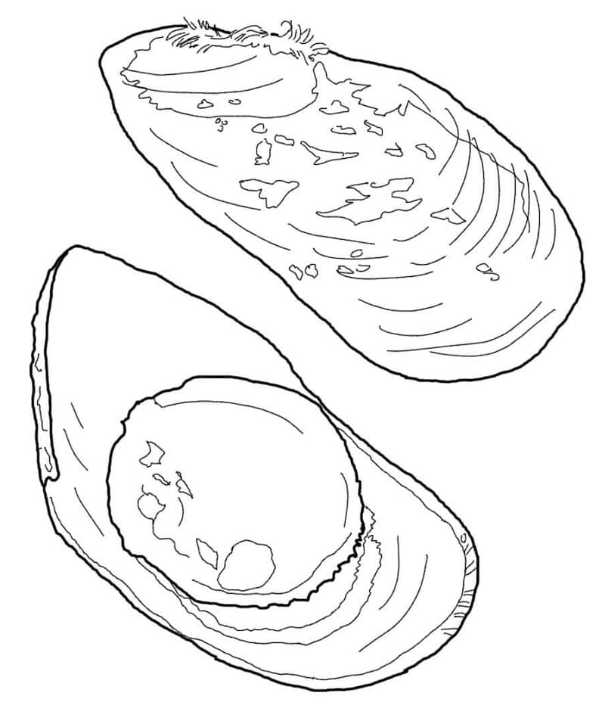

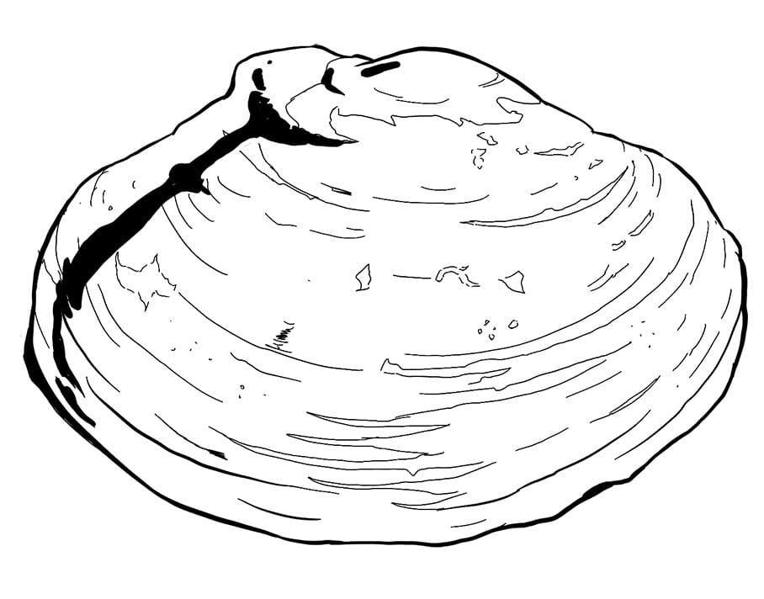

The West Virginia Department of Agriculture has a website dedicated to the study of ***Malacology.*** Malacology is the study of mollusks, which are shelled invertebrates like clams, snails and mussels. Anyone can be a Malacologist! Color this Malacologist and their scientific equipment.

[Mussels of WV](https://www.fws.gov/westvirginiafieldoffice/freshwatermussels.html)

[How the WV DNR Performs Mussel Surveys](https://wvdnr.gov/plants-animals/freshwater-mussels/)

[West Virginia Malacologists](http://www.wvdnr.org/wildlife/magazine/Archive/06fall/MusselBound.pdf)

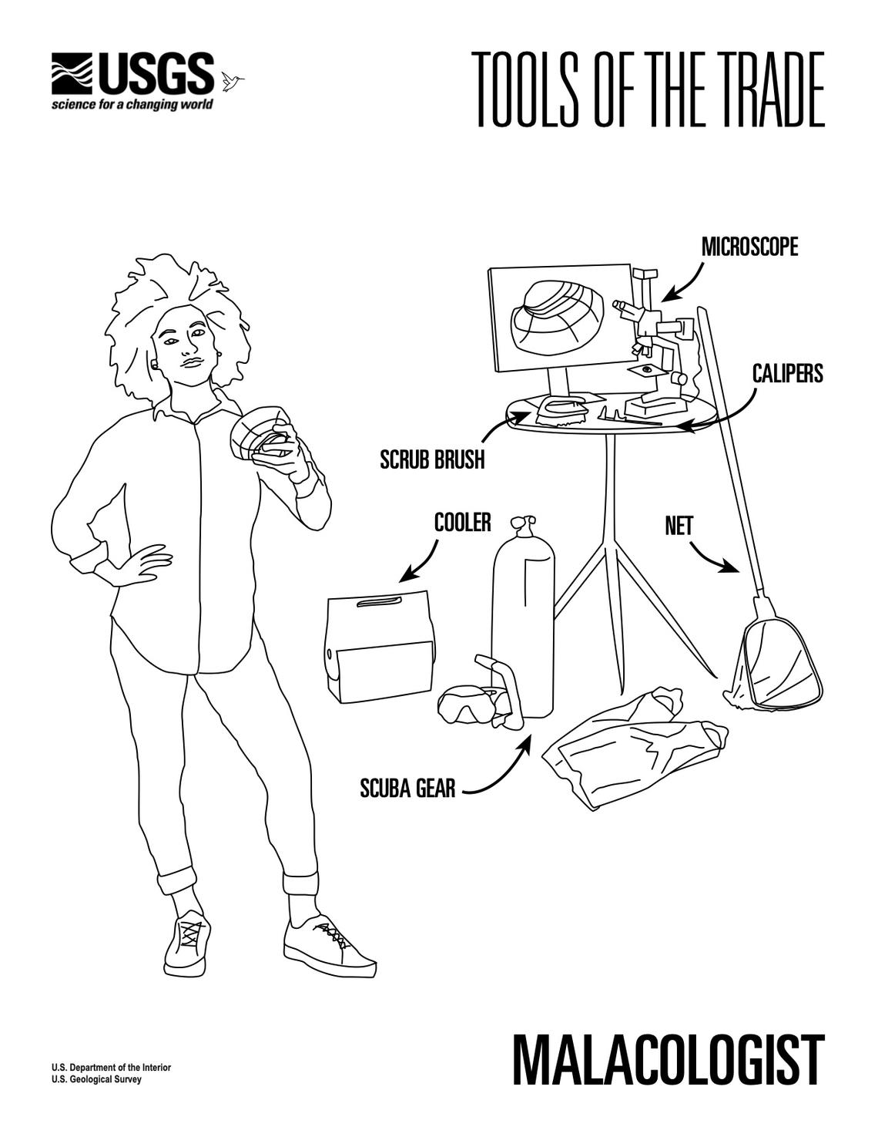

For those of you who are interested in the ecological role of human activities on mussel health the US Fish and Wildlife Service has created and provided hours or conservation videos all about mussels in the United States. Those videos can be found here.

[US Fish and Wildlife Mussel Videos](https://nctc.fws.gov/topic/online-training/webinars/freshwater-mussel-conservation.html)

**More Info on WV Mussels**

[Endangered WV Mussels Declared Extinct](https://www.wvgazettemail.com/news/mollusk-once-abundant-in-wv-among-23-species-to-be-declared-extinct/article_1a00ea46-e334-5270-a5d9-e6e638e78e17.html) - Charleston Gazette-Mail

* We also have mussels occurring in our state's lakes and ponds
* Mussels grow by secreting new shell from their mantle - the outermost soft part of their body
* There ARE clams in our freshwater, we have *native* fingernail clams (which as they sound, are tiny) as well as *non-native* and invasive Asian clams. Another Biologist summed up the difference "If it's symmetric (if you folded it in half would it look the same on both sides?) it's probably a clam"
  + The internal anatomy used to tell them apart is actually LATERAL teeth, not cardinal teeth as I stated.