
More On Marvelous Mushrooms

Identifying Mushrooms
There are many resources available to help you identify mushrooms.

Online Resources
Websites can help you understand mushrooms better and learn how to identify them. Social media resources like Facebook groups can be very important if you're looking to find the specific species of a mushroom. Experts are able to share their knowledge on your mushroom and point out important features that help identify it relatively quickly.

MushroomExpert.Com
Key to Major Groups of Mushrooms
How to Identify Mushrooms and Where to Find Them
"Yellow Elanor" Youtube Channel

Facebook Groups
West Virginia Mushroom Club
WV Mushroom Hunting
West Virginia Mushroom Hunters

Dead man's fingers Jack o’ lantern mushroom
(Xylaria polymorpha) (Omphalotus illudens)
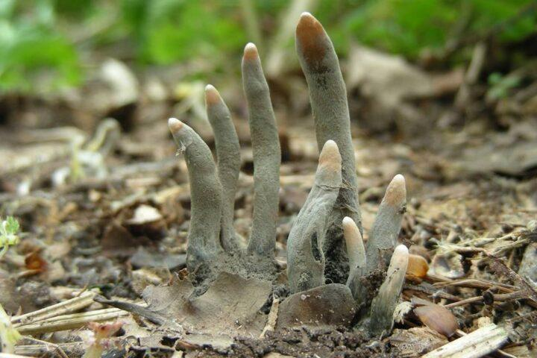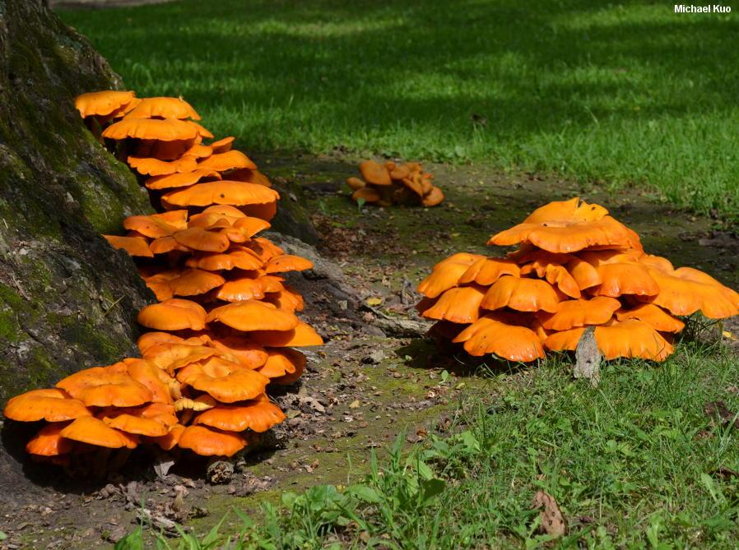
From Charismatic Planet Photo by Micheal Kuo

Mushroom Identification Books
Field guides are a great way to learn different characteristics of mushrooms. These can be cap shape, rings, stem shape, gills, pores and other features. Field guides also have information on season, substrate – growing surface - and other helpful location information. Sometimes you may not be able to get to your specific species using a field guide, but it can help you narrow down the possible ID.

It's very important to look at multiple resources, not just books, if you are wanting to know the species of the mushroom. This is most critical if you plan on eating the mushroom. Many mushrooms have dangerous look-alikes, so you should never eat a mushroom unless it has been identified, verified and reverified as edible from several reliable sources.

Mushrooms of West Virginia and the Central Appalachians
Appalachian Mushrooms: A Field Guide
Mushrooms of the Northeastern United States and Eastern Canada
Ascomycete Fungi of North America: A Mushroom Reference Guide

Spore Prints
A spore print is a collection of spores that have been released from a mushroom cap on a particular surface. This spore print is unique to each mushroom. Spore prints are important when identifying mushrooms because of the huge amount of look-alikes that exist among mushrooms. Two mushrooms may look very similar but one may have a purple spore print and the other a black spore print. You now see that they are actually two different species!

Surfaces such as paper, tinfoil, and glass can all be used for spore printing.

- For mushrooms with gills: simply cut the stem off of the mushroom and place the cap with the gills facedown on your surface.
- For mushrooms that have other forms: you must identify where their spores are released from and then place them accordingly so the spores will be released on your surface.

You can preserve your spore print by spraying hairspray on your surface afterwards.

Spore Prints

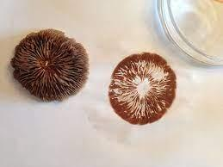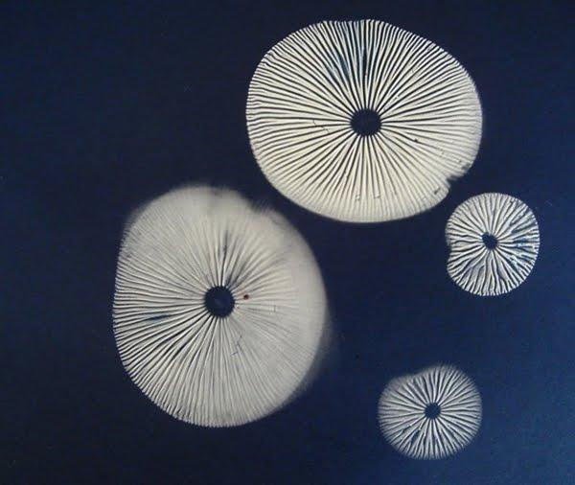
Photo from Milkwood Photo from Milkwood

Eating Mushrooms

There are plenty of edible mushroom species that are tasty to eat. They have an earthy, sweet, and umami taste that can go with many different things. This meaty and savory umami taste explains why mushrooms are used as meat substitutes in many dishes. Mushrooms can go in most food, and because of their availability, are very commonly eaten in West Virginia. Wild puffballs, chanterelles, oyster mushrooms and chicken mushroom are the most commonly eaten mushrooms in West Virginia and can be found in many parts of the state. This availability in the US has inspired cookbooks and many recipes that you can find online. One book, The Mushroom Hunter’s Kitchen is an entire book about foraging and cooking mushrooms with many great recipes in all categories of flavor. Books like this can help you with both your identification and cooking skills.

The Mushroom Hunter's Kitchen

Growing Your Own Mushrooms

Growing your own mushrooms can also give you the chance to try different tasty mushrooms. Kits online come with mushroom spawn that consist of mycelium, the underground vegetative part of the fungi that produces mushrooms, added to a food source. Mushrooms are grown by simply misting the spawn. These mushrooms can be collected after about two weeks of misting to eat and enjoy for any recipe you may need!

Growing Mushrooms
Mushroom Grow Kit

